Explore Solar Cells
Measure the voltage, current and efficiency of solar cells

Recommended Grade Level: [ 9th to 12th grades ]

NGSS Science & Engineering Practices: [High School ]
- Asking Questions & Defining Problems. Define a design problem that can be solved through the development of an object, tool, process or system and includes multiple criteria and constraints, including scientific knowledge that may limit possible solutions.
- Planning and Carrying Out Investigations. Collect data about the performance of a proposed object, tool, process or system under a range of conditions.
- Using Mathematics and Computational Thinking. Use digital tools, mathematical concepts, and arguments to test and compare proposed solutions to an engineering design problem.
- Designing Solutions. Optimize performance of a design by prioritizing criteria, making tradeoffs, testing, revising, and re- testing.

Preparation: [ 2 to 4 hours to obtain materials ]

Materials Needed: [ For each group of 3 to 4 students ]

• Two solar cells
• Two Volt/Amp meters to measure volts (1 to 10 volts) and amps (0.01 to 10 amps)
• A metric ruler or meter stick
• 5 clip leads with two alligator clips on each end. Two red, two black, one another color.
• Sunlight (Optional for in classroom use on a cloudy day a 100 Watt incandescent bulb in a gooseneck lamp)
• A small DC electric motor that will run on 0.5 volts.
• A small piece of masking tape.
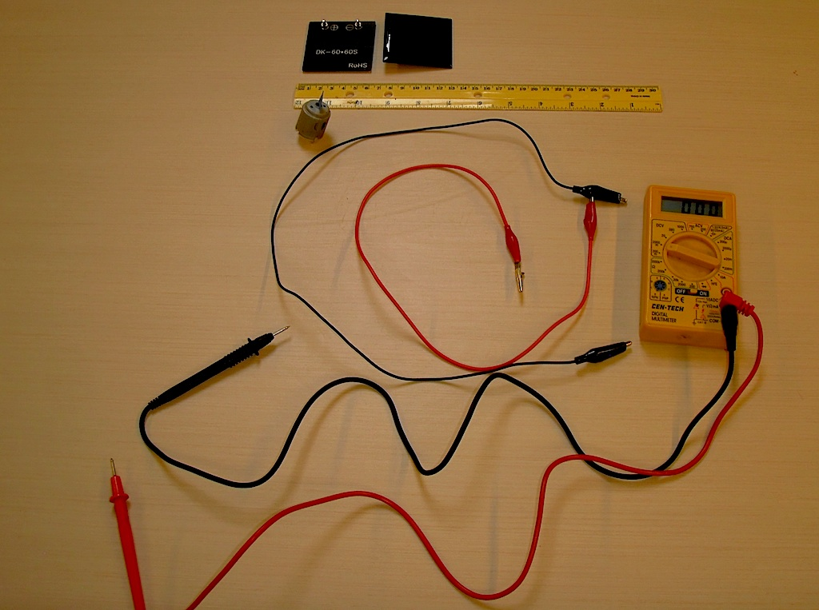

Background Information
Solar cells convert the energy in light into electrical energy. Measure the voltage across the terminals of a solar cell and the current flowing through to solar cell to find the power delivered by the solar cell. Calculating the ratio of electrical power out to solar power in to estimate the efficiency of the solar cell.

What To Do

Measure the open circuit voltage of the solar cell

In a sunny place (or under a floodlight) Set the meter to the DC voltage scale so that it can measure a few volts. Connect the positive terminal of the meter via a red clip lead to the positive terminal of the solar cell, and the common or COM terminal of the meter with a black clip lead to the negative terminal of the solar cell. A voltmeter has very high input impedance (resistance) so connecting a voltmeter across a solar cell is similar to an open circuit. Measure the voltage across the solar cell, this is called the open circuit voltage of the solar cell, Voc. Investigate how the Voc changes as you tilt the solar cell.

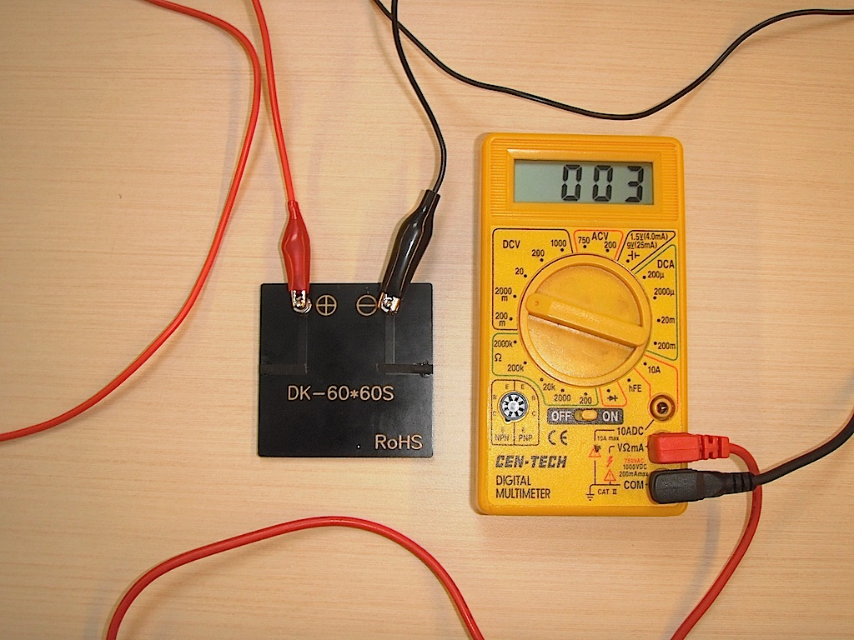
In this image we show the connections on the back of the solar cell.

Measure the short circuit current through the solar cell

Set the meter to measure DC amperes so that it could measure a few amperes of electrical current. Connect the positive terminal of the meter (there may be a separate terminal for measuring amperes.)via a red clip lead to the positive terminal of the solar cell, and the common or COM terminal of the meter with a black clip lead to the negative terminal of the solar cell. An ammeter has very low input impedance (resistance) so connecting an ammeter across a solar cell is similar to a short circuit. Measure the current through the solar cell, this is called the short-circuit current, Isc. Investigate how the Isc changes as you tilt the solar cell.

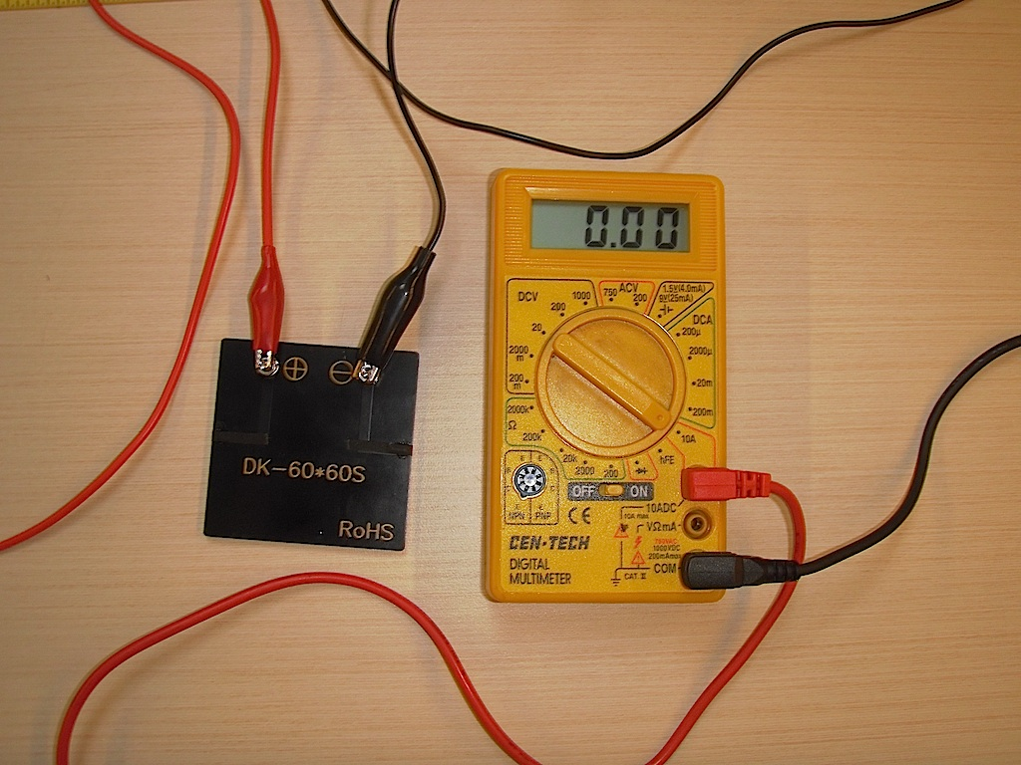
Some meters require moving the input lead to measure amperes.

Investigate a solar powered motor

Put the piece of masking tape on the shaft of the electric motor. Connect the two terminals of the solar cell to the two terminals of the electric motor.
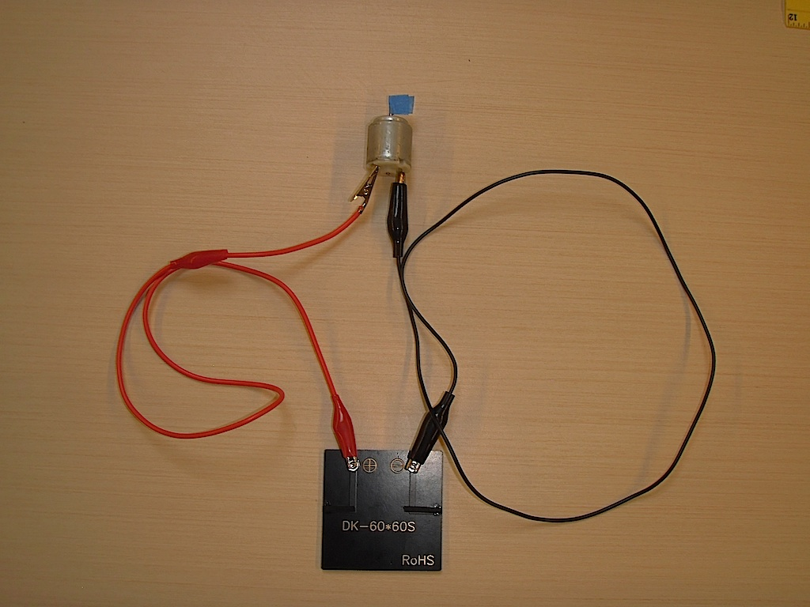
Notice how the motor shaft spins when the solar cell is in the sun. Tilt the solar cell to maximize motor speed. Notice how motor speed changes as you tilt the solar cell away from its maximum orientation. Be careful not to shade the solar cell as you tilt it. Notice that power production is greatest when the solar cell is oriented perpendicular to a line radiating out from the sun that passes through the solar cell.

Measure the voltage across the motor as it runs at maximum speed.
Measure the current through the motor.

You can use two meters to measure voltage across the motor and current through it at the same time, or use one meter to make two measurements.

For our solar cell and motor combination we measured 1.1 volts and 0.11 amps.
The power provided to the motor is P = V*I = 1.1 * 0.11 = 0.12 W
The resistance of the motor is R = V/I = 1.1/0.11 = 10 ohms
(Lori Lamberston notes that Power P is a Product while resistance R is a Ratio.)

Estimate the maximum power and efficiency of the solar cell

To make a first estimate of the maximum power of the solar cell multiply the short circuit current times the open circuit voltage. Note, a solar cell can never produce this much power because you cannot have both an open circuit and a close circuit at the same time. This is a good first estimate of maximum power. We’ll actually measure the maximum power in the optional section below.

To find the efficiency with which the solar cell converts solar power into electrical power we need to know the solar energy arriving at the cell.

Measure the area of the solar cell. Our cells were 5 cm x 5 cm for an area of 25 cm² or 0.0025 m².

The power in sunlight, I_{s}, at sea level, at noon is about 1,000 W/m^2

So calculate the solar power into your solar cell P_{s} = I_{s} *A = 1,000 * 0.0025 = 2.5 W

The efficiency is P/ P_{s} which if the maximum possible power produced by the solar cell were 0.4 W would be 0.4/2.5 = 16%.

What’s Going On?

Solar cells convert light energy into electrical energy, this is called the photovoltaic effect. The solar cell may be made of the semiconductor silicon. In crystalline silicon the outermost electrons are held in place in covalent bonds between silicon atoms, they are said to be in the valence band. However, an electron can absorb the energy from a photon. If it absorbs enough energy it can cross the bandgap to enter the conduction band. The electron is free to move through the conduction band. (In addition the electron leaves behind a silicon atom that is missing one electron, this silicon is a positive hole. Other electrons can move into the hole so that the hole can move as well. Now we have to get the electrons to move in one direction.

Impurities are added to the silicon, this is called “doping” the silicon. One part of the silicon is doped with an atom from the column in the periodic table to the right of the column containing silicon, such as phosphorus, when the phosphorus replaces a silicon in the crystal structure it brings an extra electron, this excess negatively charged electron makes the silicon a so-called n-type silicon where electricity is carried by electrons. Similarly when a silicon atom is replaced by an atom from a column to the left, such as boron, there is one fewer electron resulting in a positively charged hole, creating a so-called p-type silicon where electricity is carried by positively charged holes. When a p-type silicon is placed against an n-type silicon it forms a diode and allows electric current to flow in one direction. So, when light falls on a silicon p-n junction diode an electric current is created with a voltage equal to the band gap voltage, 0.6 volts for silicon.

So basically solar cells are built by combining 0.6 volt modules in series. The cells produce one electron for every photon absorbed, some of these electrons recombine with holes before they get out of the cell. So solar cell voltage is insensitive to the illumination, but solar cell current is sensitive to illumination.

In addition, a solar cell has an internal resistance, R_{s}. When current, I_{L} flows through the solar cell, it flows through this resistance and decreases the voltage available at the outside terminals of the solar cell. Solar cells are built with a low internal resistance, our cell has an internal resistance near 2 ohms. So it takes a large current to create enough voltage to decreases the voltage output.

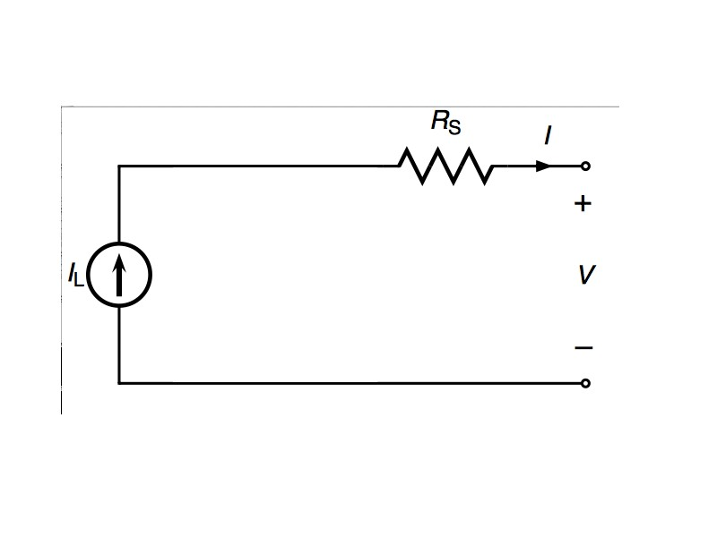
Solar cell simplified internal circuit

Going Further (optional)

Use a 10 ohm potentiometer to measure the voltage versus current curve for your solar cell to find the true maximum power. Put the solar cell in series with the potentiometer and the ammeter. Then connect the voltmeter across the terminals of the solar cell. As you vary the resistance the voltage across and the current through the cell will change. Graph the change.
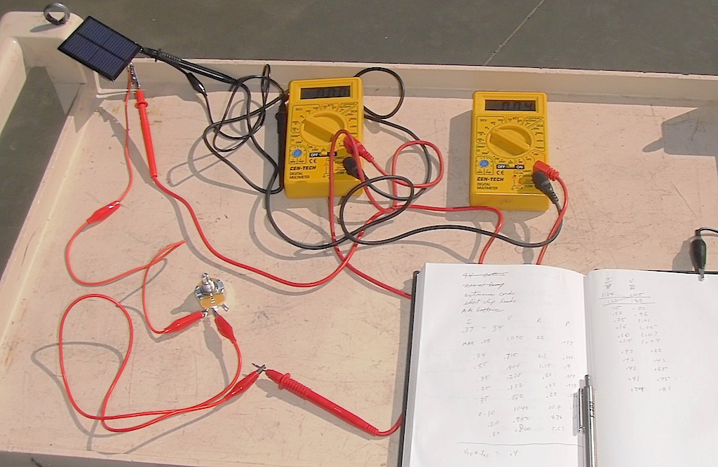

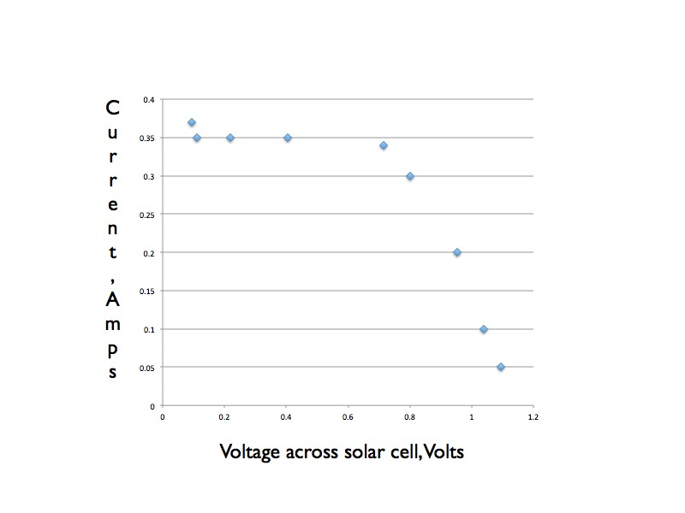

The current through the solar cell remains constant across a wide range of voltages.
Current flowing through the solar cell decreases the maximum voltage across the solar cell. So, to reach the highest voltages across the solar cell the current must be reduced.

Recommended Web Sites
Solar Schoolhouse

More

To estimate the error in a voltage or current measurement use a second meter. Measure the voltage across the solar cell using one meter, then add in the second meter and observe the change in the reading if any. You can estimate that the change in the reading by adding a second meter is the same as the reading from the actual value caused by adding the first meter. This will serve as an estimate of the error in your measurement. To estimate the error in a current measurement, start by measuring the current with one meter, then, add a second meter in series. The change in the measurement will be an estimate for the changed caused by your first meter. Try this for the meter on the 10 amp scale and then with the meter on a lower amperage scale, such as a 2 amp of 2000 mA scale, you might be surprised by the size of the error.

